Introduction

The first piece of coursework required a website to be built using only HTML,CSS and JavaScript. The website is to allow the user to type in a message and then encode and display the message. There must be a method for choosing between ciphers and display the decoded message to the user. My website makes use of a Caesar Cipher, Morse Code Cipher and base-64 encoder. These 3 weren’t that difficult to implement and so I chose them because I’m new to JavaScript and I didn’t want to put in ciphers I didn’t understand. My site uses 3 textboxes, one for plaintext, one for encoded text and one to output decoded text. There is an encryption and decryption button that have two functions per cipher/encoding method. When the button is pressed it calls the function based on I chose this rather than 2 text boxes so that no text was overwritten in any text box when the user tried to cipher or decipher something, unless they changed the cipher or shift. I used a drop-down menu to allow the user to change cipher/encoding method rather than them having to navigate to a new page each time. I put in a small about section explaining each cipher/encoding method to give the user a bit of understanding. Before implementing my ciphers, I had to do a lot of reading about what ciphers/encoding methods I wanted to use. This meant quite a bit of reading on Practical Cryptography(Lyons, 2012), Stack overflow, Wikipedia, W3schools and going through my old lecture notes from last year’s cryptography class to understand the ciphers, and maths behind the Caesar cipher.

Software Design

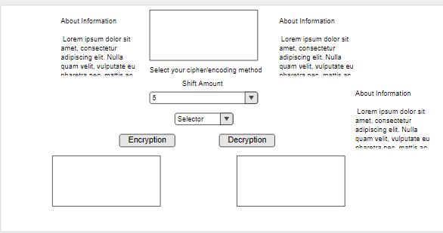To begin I used the list of requirements to build a wireframe to be sure the user could do everything the requirements asked. 3 text area’s,2 buttons, 2 drop down menus and some information on the ciphers/encoding methods.

Implementation

I began with the HTML and CSS before giving any functionality to the site. I went for a colourful approach to be more inviting to the user and a simple layout so there is no messing around with navigation. I gave my text areas some border highlighting and coloured the text of my buttons and drop-down menu’s purple to blend with the background image well. I also put some animation on the buttons for a bit of flair. After the look and feel of the site was completed, I began working on functionality, I started with the base-64 encoding as this was the easiest

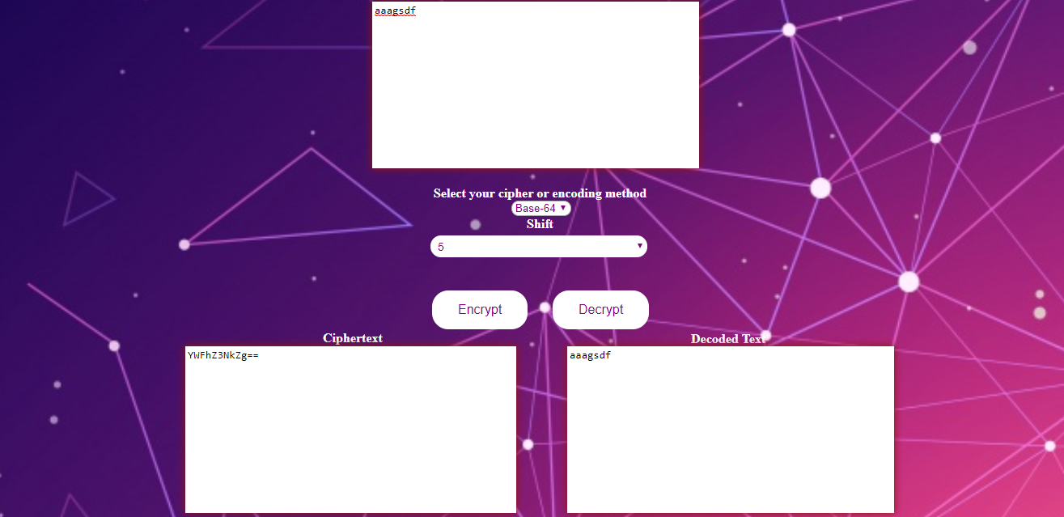

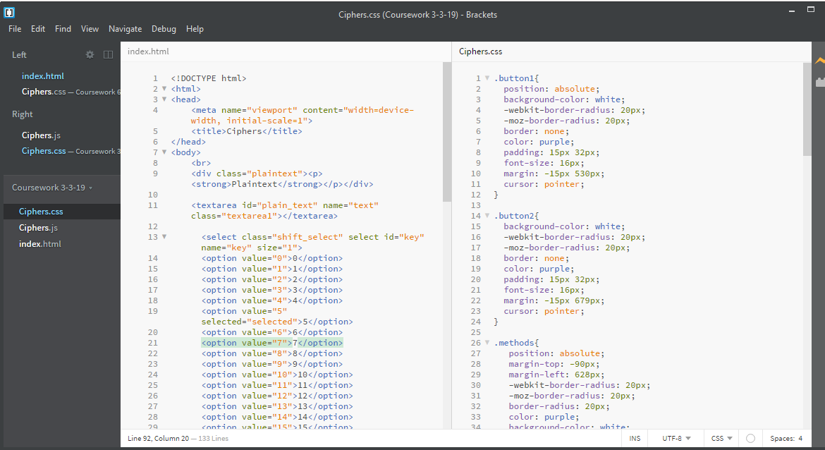

Critical Evaluation

My website makes use of two-character encoding schemes and a cipher, which meets the 2 minimum requirements however i think looking back 4 cipher/encoding schemes or more complex ciphers would have been a greater challenge to take on. The 3 in my website were not overly difficult and only the Caesar cipher uses additional user interaction in selecting the shift. The site also could have made use of additional pages, although because on my application you don’t need to change pages to select a new cipher/encoding scheme these pages would have likely just been more ‘about’ pages or other additional information not relevant to the specification. I also noticed after most of the JavaScript was completed my code seems to follow a pattern because I was using a switch statement for all my functions, they all started and ended almost the same and the only difference was in the middle. A big change I would look to make in the future is to reduce the number of functions and have any decryption methods in the same function as the encryption methods if possible. It would also be good in the future to have given my shift selector more purpose by having additional ciphers that use shifting. Having them separate is easier I found because generally you are just reversing what you did before; or just changing the maths around, so really its just a copy and paste method changing only a little bit around. There is a lot of CSS and I chose to give individual elements there own class and positioning absolute so I could move everything exactly where I wanted it, this presented a problem later on when I tried my site on different resolution and different sized monitors as some of my elements would move around and not stay fixed, in the future I would like to use maybe an inline block or just group set elements together so the flow together on the page. I would like to swap fonts from using percentages to ems to make it more scalable. The HTML of my site I’m pleased with but for the next coursework I would like to add more div tags to group content together, so they are easier to implement in CSS. My website only makes use of one page, which I feel makes it seems a bit emptier than I would have liked, although as I said in my introduction, I didn’t want the user to have to change pages frequently.

Personal Evaluation

This was my first attempt at building a website

# References

Lyons, J., 2012. Practical Cryptograpy. http://practicalcryptography.com/ciphers/caesar-cipher/

https://developer.mozilla.org/en-US/docs/Web/API/WindowBase64/Base64_encoding_and_decoding

<https://en.wikipedia.org/wiki/Base64>

<https://en.wikipedia.org/wiki/Morse_code>

<https://image.freepik.com/free-vector/technology-background-with-gradient-colors_23-2147837710.jpg> <-- background image

<https://morsecode.scphillips.com/morse2.html> <-- morse code alphabet used